Blue (Metasploit) - Lab Report

Date: 29/05/2026
Difficulty: Easy
Category: Exploitation
Platform: TryHackMe

Overview

This lab walks through the steps in order of how to successfully use Metasploit to scan, gain access, escalate privileges and crack a user’s password. It looks at the Eternal Blue MS17-010 vulnerability on the target machine.

2. Toolset Used

Tool | Purpose / Function
Nmap | Port scanner to find open ports and vulnerabilities on the target
Metasploit | Exploitation framework which supports all phases of a penetration test to gather information, scan targets, exploit targets and run post-exploitation processes using various built-in tools and techniques.

3. What I did

Scanning

The first step is reconnaissance which involves scanning the target to look for any open ports as a way of entry. To do this, I used Nmap which is a port scanning tool used to find open ports and service versions.

The Nmap command I used was “Nmap -sV -vv --script vuln 10.80.163.164”
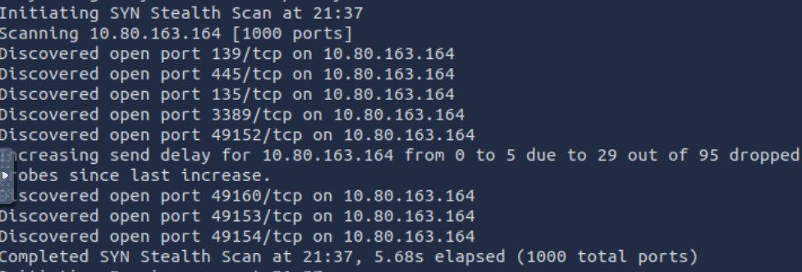

The scan also showed that the target machine was vulnerable to MS17-010 (Eternal Blue)
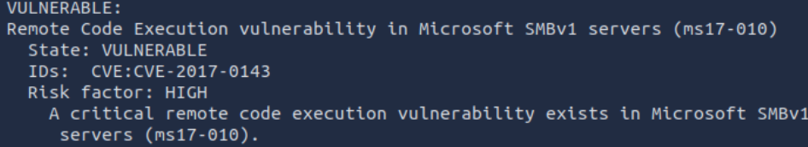

Gaining Access

To gain access, I used Metasploit to search for MS17-010 and it returned an exploit to run against the target machine - exploit/windows/smb/ms17_010_eternalblue. I set the RHOSTS as the target IP address and then set the payload to windows/x64/shell/reverse_tcp.

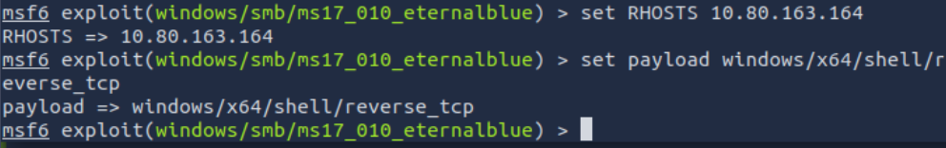

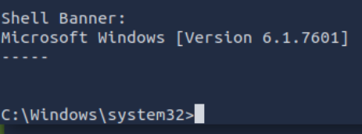

Escalation

Firstly, I backgrounded the shell so that I could convert the shell to a meterpreter shell by using the post/multi/manage/shell_to_meterpreter module. I then showed the options, and I set the session to session 1.

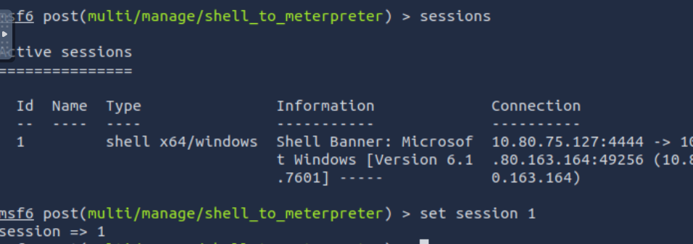

Next, I ran that exploit and selected that session. Now I have escalated to NT AUTHORITY\SYSTEM
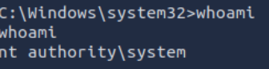

The ps command shows all the processes and these ones below are running at NT AUTHORITY\SYSTEM, so I migrate to one of them by using the migrate command. I selected Powershell.exe which was PID 3036.
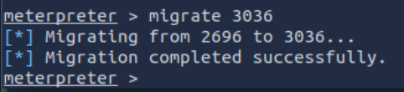

Cracking

To find the user’s passwords, I used the hashdump command in the meterpreter shell to view the hashes of the users.

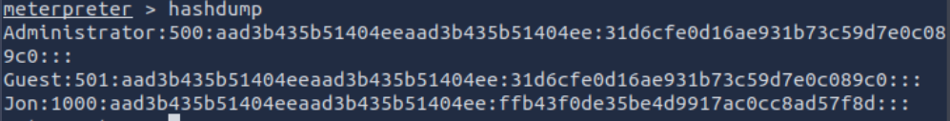

I used CrackStation to crack the hash of the Jon user

4. What I’ve learned

- How to exploit the MS17-010 vulnerability
- Gain hands on experience of each stage and understand how to do it
- Navigate around Metasploit

